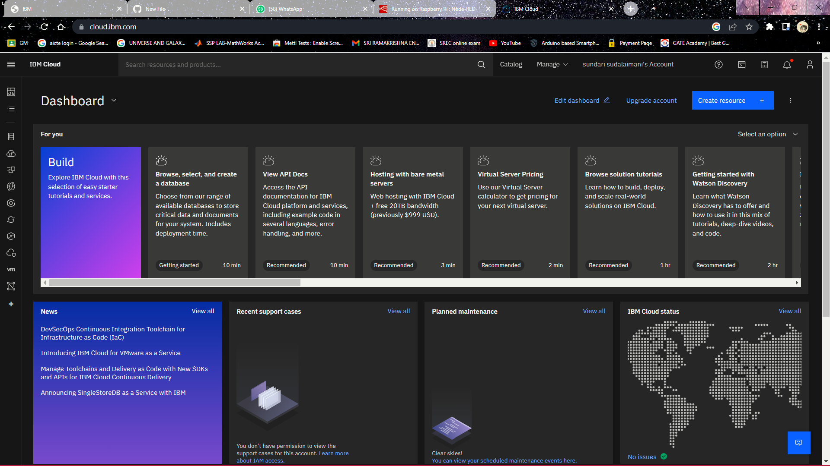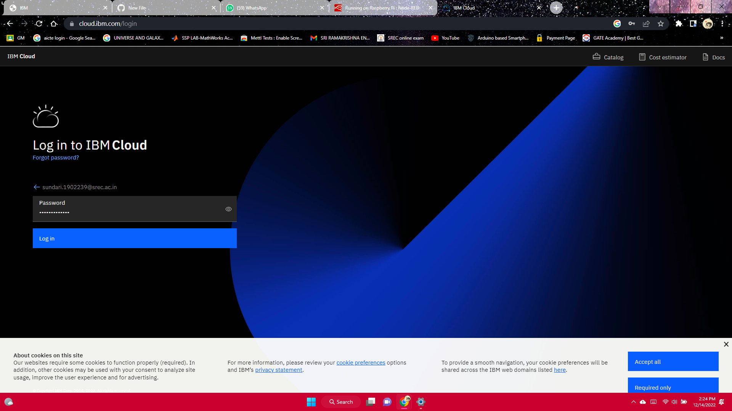**CREATE IBM WATSON IOT PLATFORM AND DEVICE**

**ACCOUNT CREATED SUCCESSFULLY.**